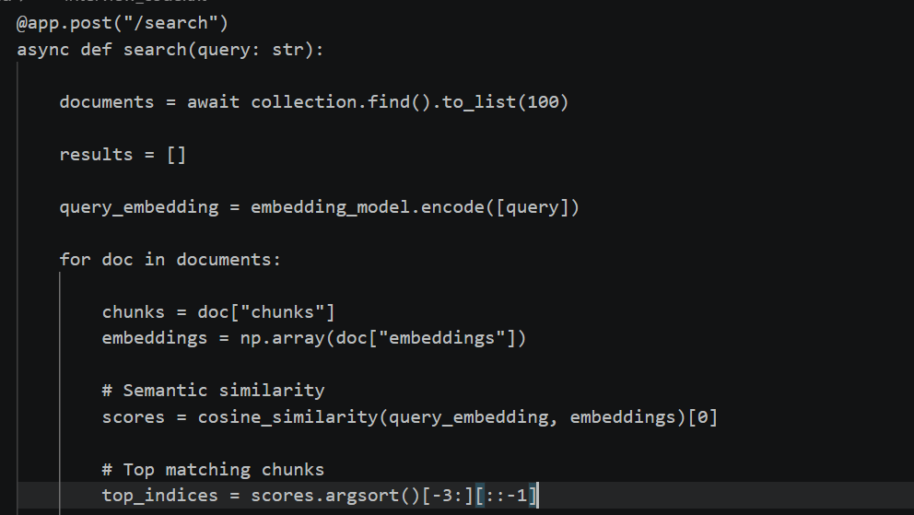
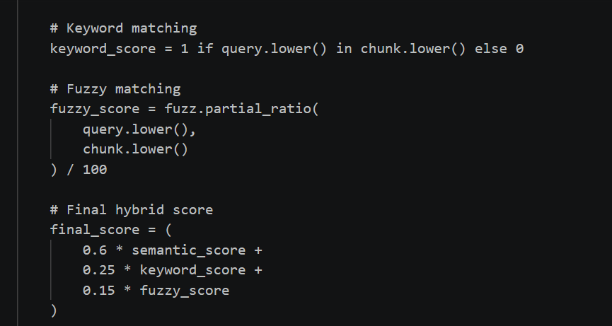
“Explain your /upload API.”
Then:
“The /upload API receives the PDF, extracts its text using PyPDF2, divides the text into chunks, generates embeddings using Sentence Transformers, and stores the required information in MongoDB.
“What does /search do?”
“The /search API receives the user's query and performs hybrid retrieval by combining semantic similarity, keyword matching and fuzzy matching to identify the most relevant document chunks.”

“What does /chat do?”
“The /chat API takes the user's question, retrieves the relevant chunks using the RAG pipeline, constructs the prompt with that context, sends it to Mistral, and returns the generated answer.”

